**RDBMS PROJECT**

**TOPPIC:-EMPLOYEE MANAGEMENT SYSTEM**

1)VISHAL PATIL(1606097)

2)NIRAJ RASAL(1606102)

3)NILESH NIVANUNE(1606092)

CREATING TABLE:

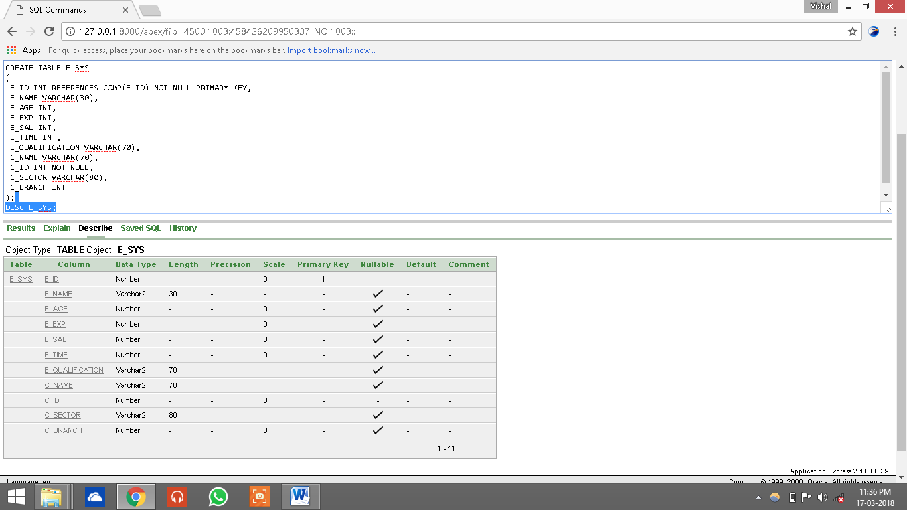

PRIMARY KEY & FOREIGN KEY:



INSERTING DATA INTO TABLE:

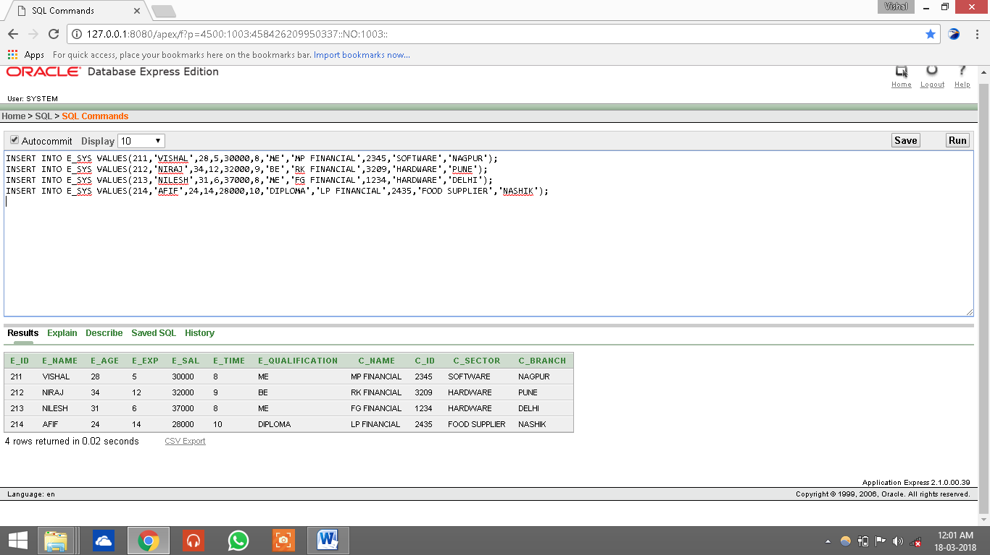

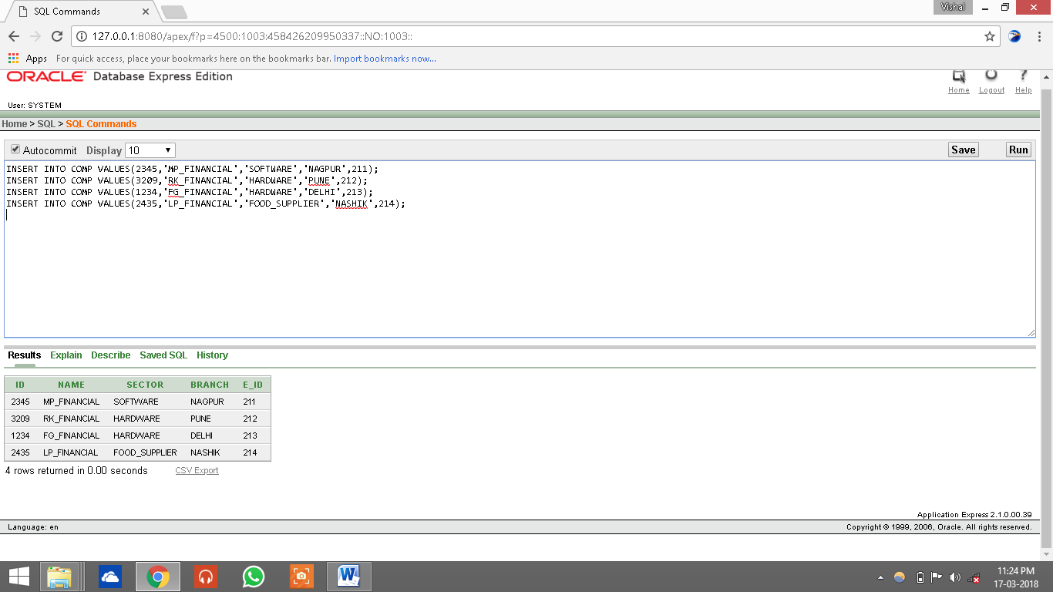

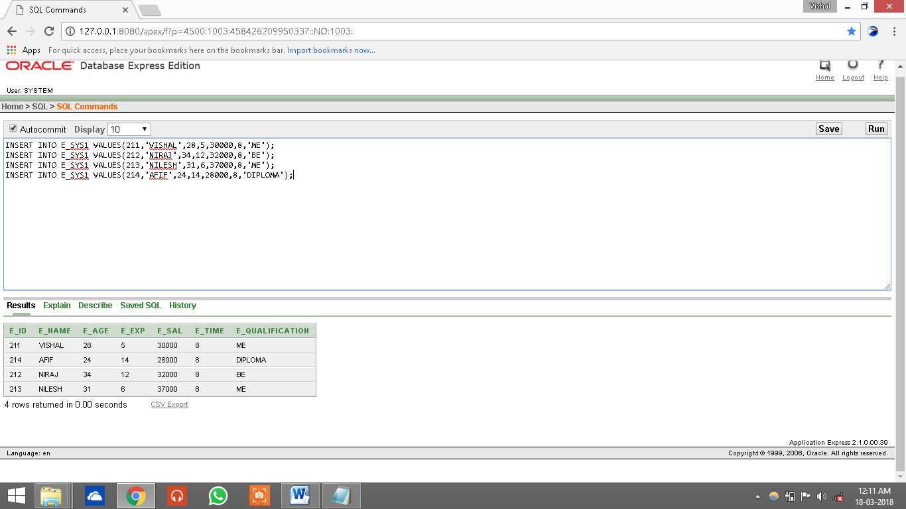

UPDATING CONTENT OF THE TABLE:-

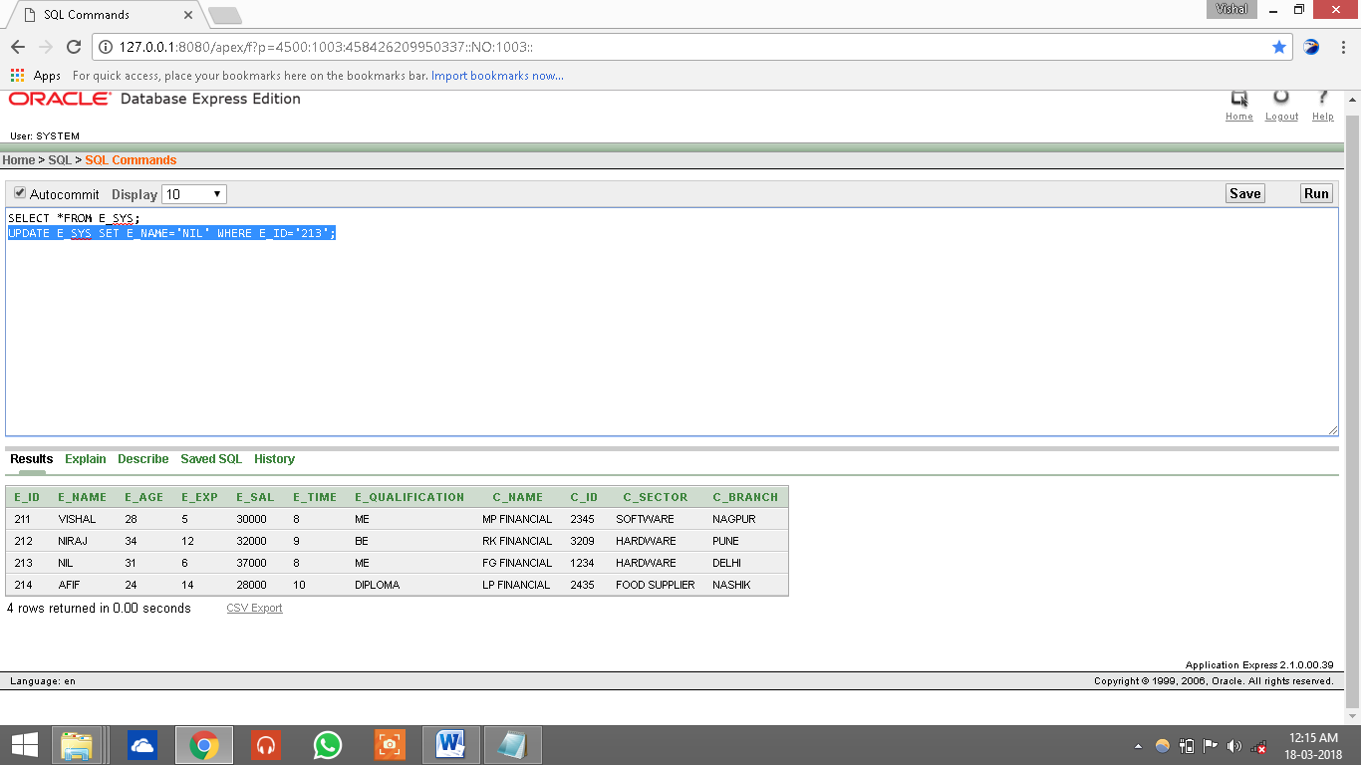

DELETING CONTENT FROM TABLE:-

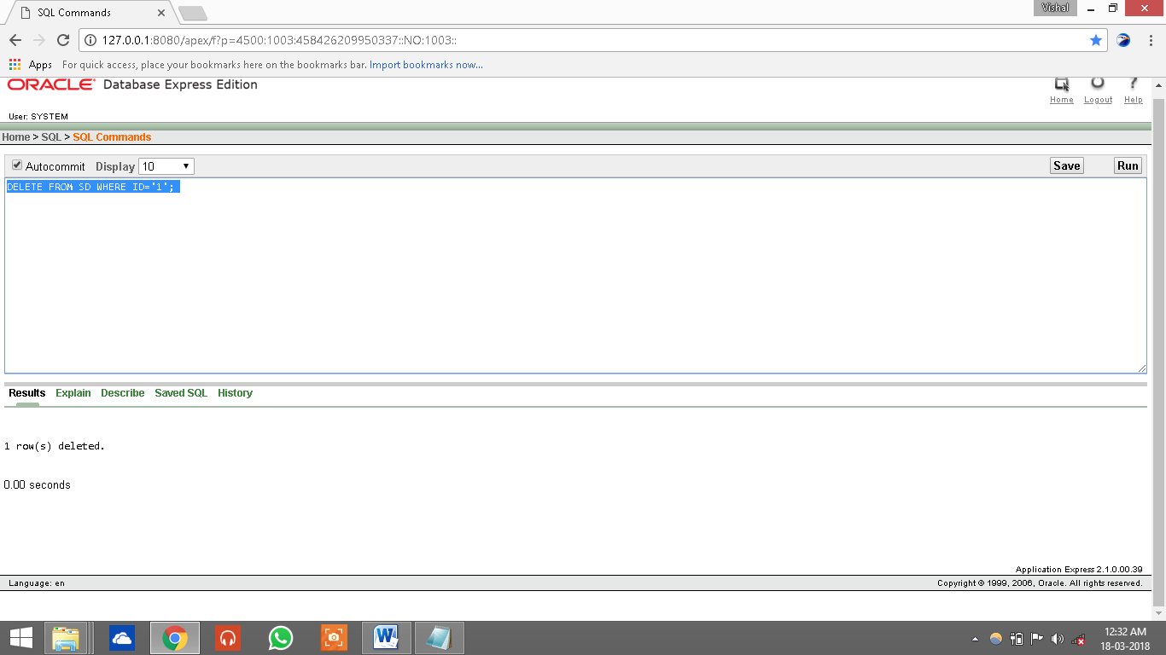

RENAMING TABLE:-

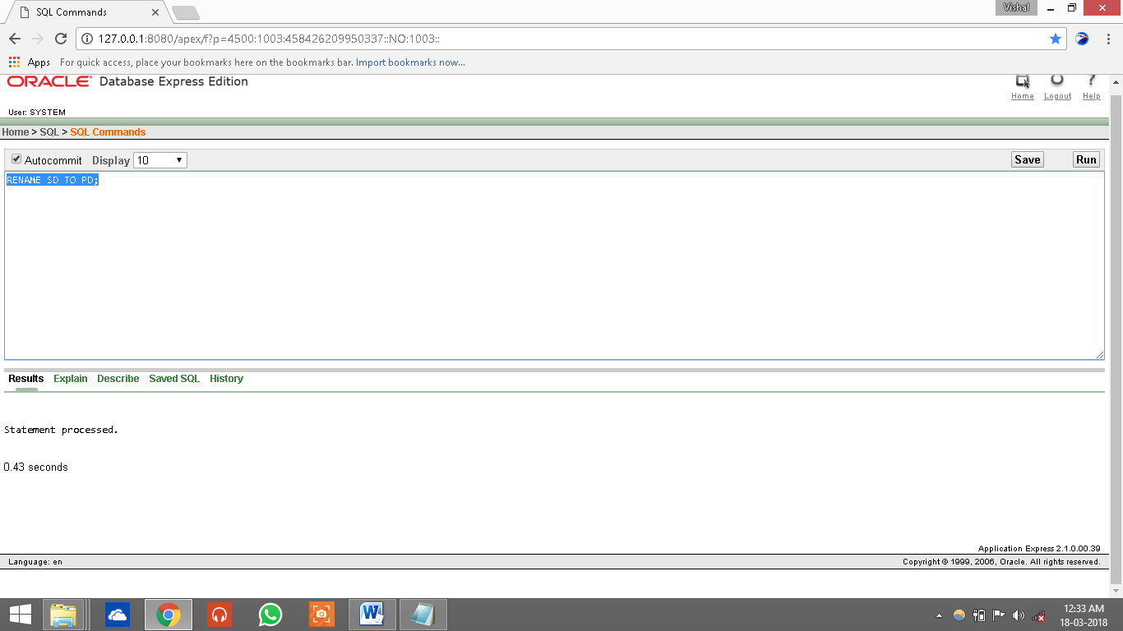

CONSTRAINTS:

KEY CONSTRAINTS:

1)PRIMARY KEY CONSTRAINTS:

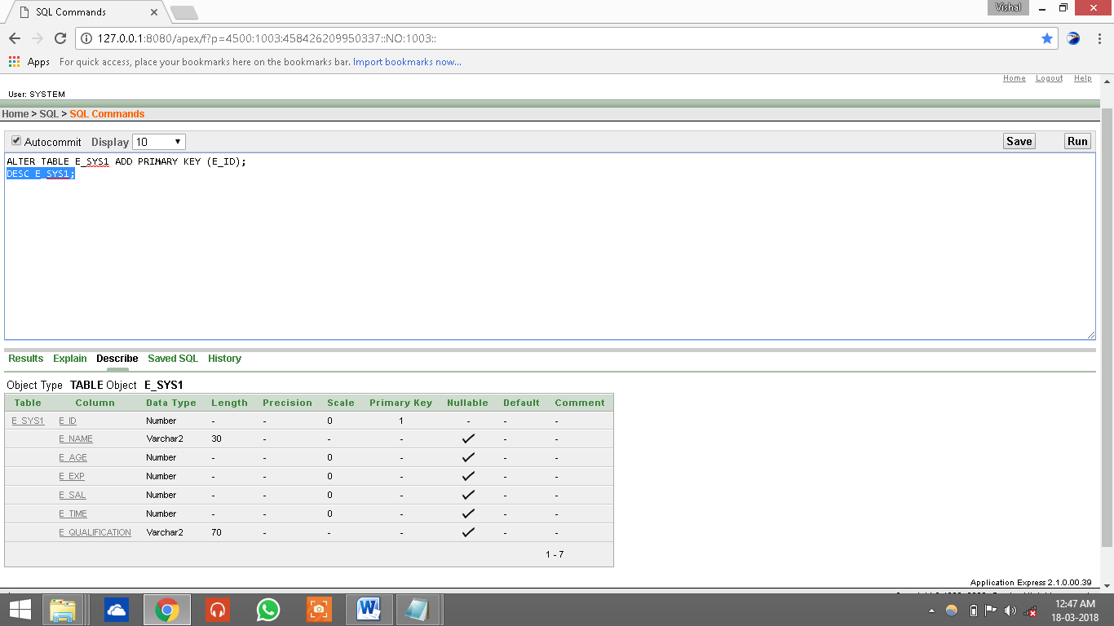

2)UNIQUE KEY CONSTRAINT

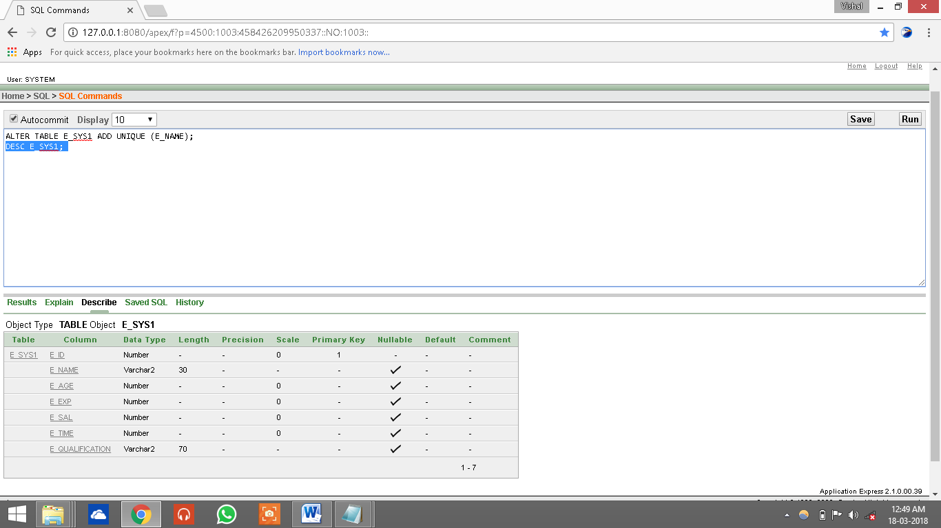

3)FOREIGN KEY CONSTRAINT:-



4)NOT NULL CONSTRAINT:-



**Operators:-**

**1.Comparison OR Relational Operators**

**2.Logical & Conjunctive Operators**

**3.Operators for Negating Conditions**

**4.Arithmetic Operators**

**1.Comparison OR Relational Operators:-**

**<EQUALITY OPERATOR>**

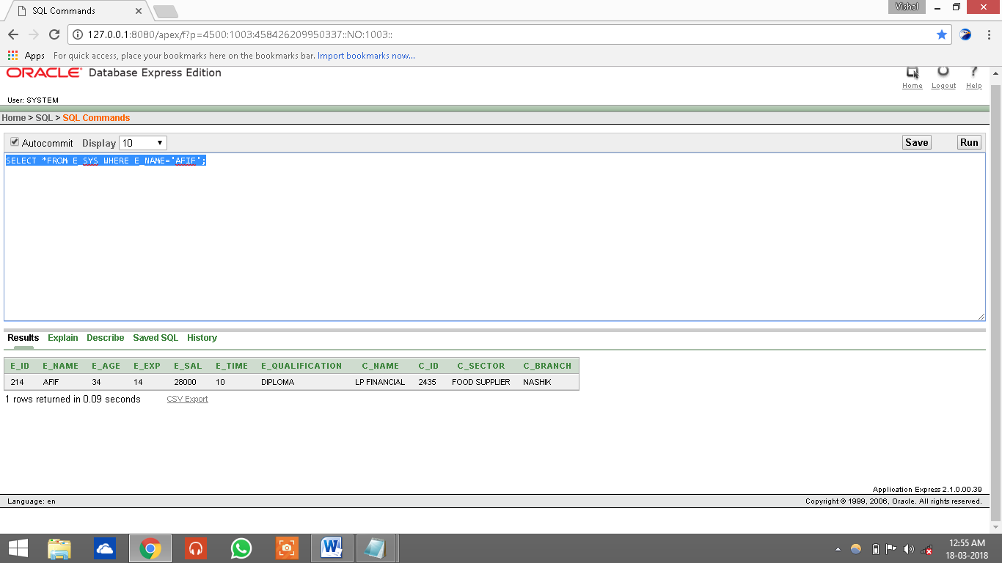

**<NON-EQUALITY OPERATOR>**

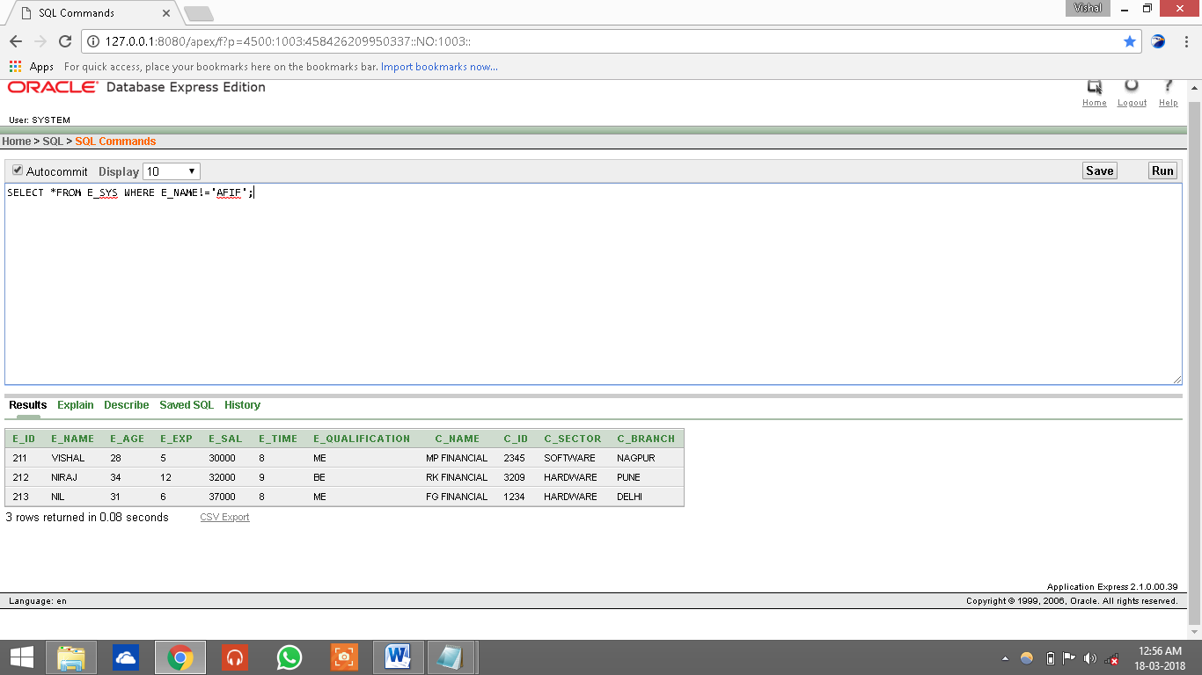

**<GREATER THAN OPERATOR>**

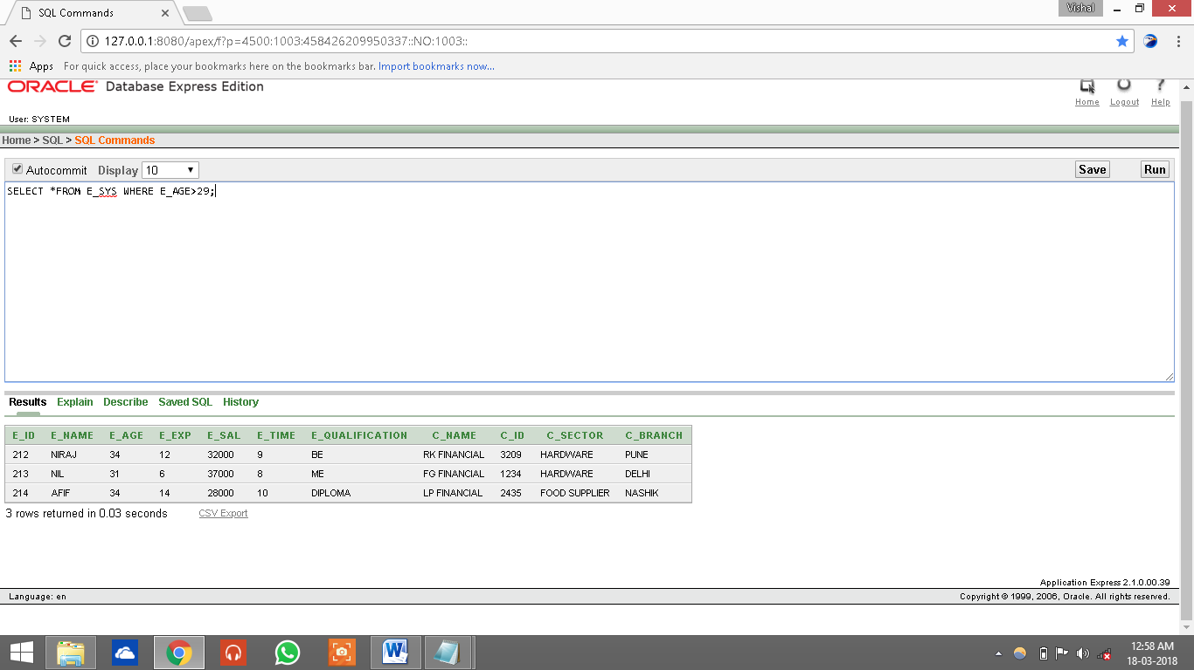

**2.LOGICAL OPERATOR:-**

**<IS NULL OPERATOR>**

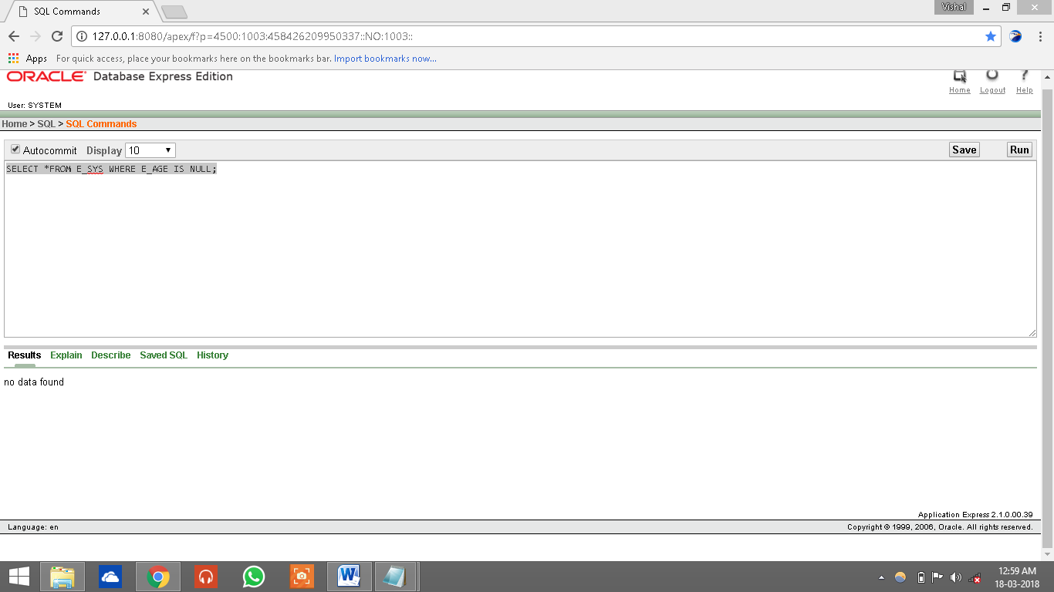

**<BETWEEN OPERATOR>**

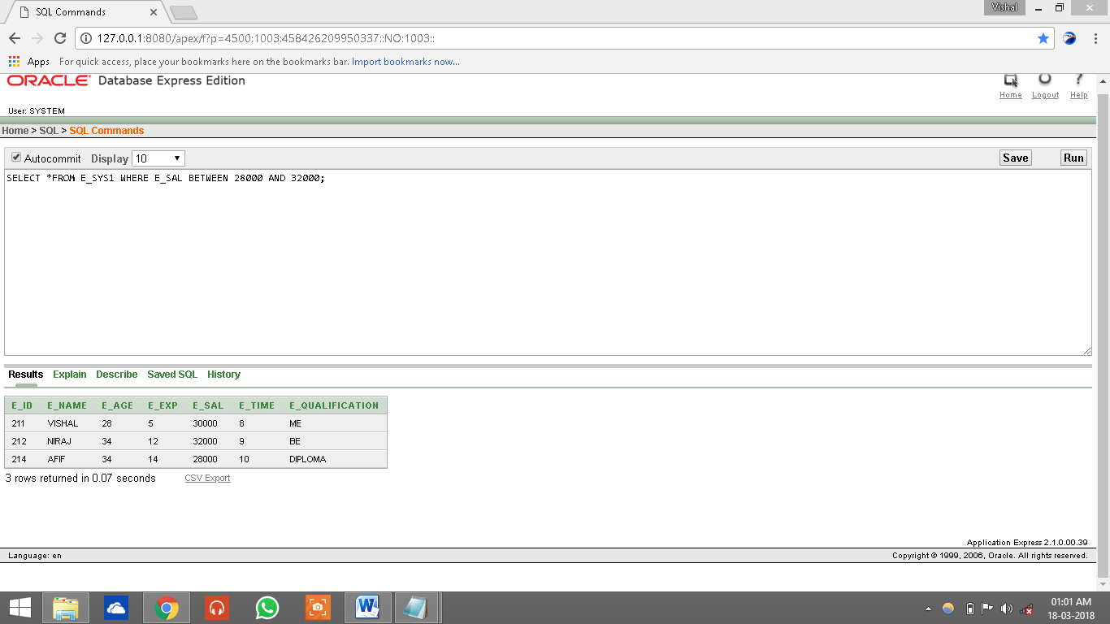

**<IN OPERATOR>**

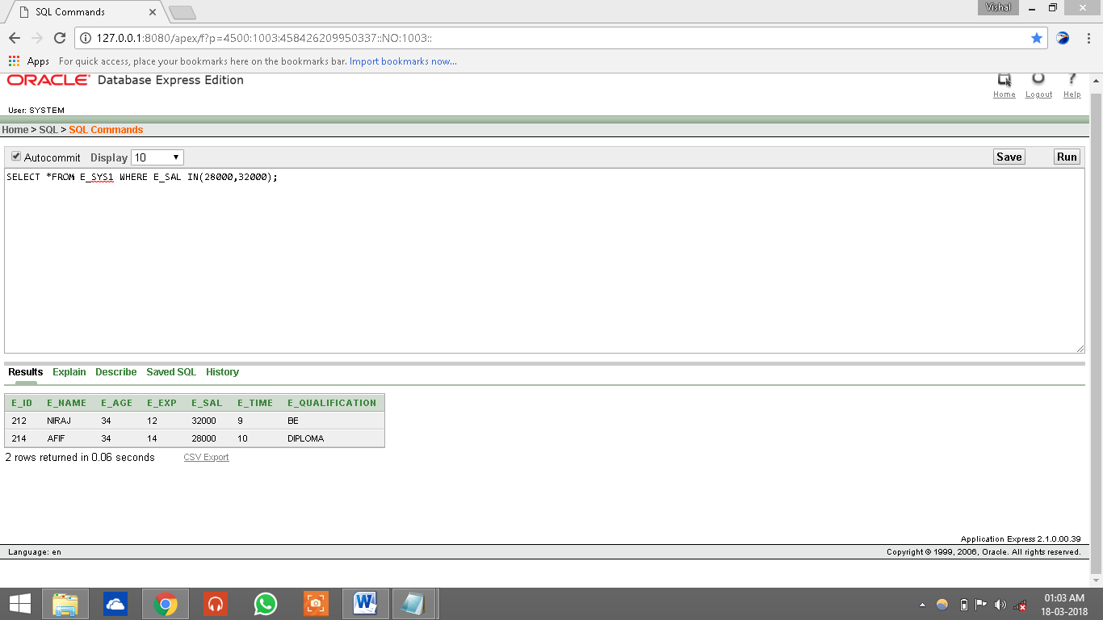

**<LIKE OPERATOR>**

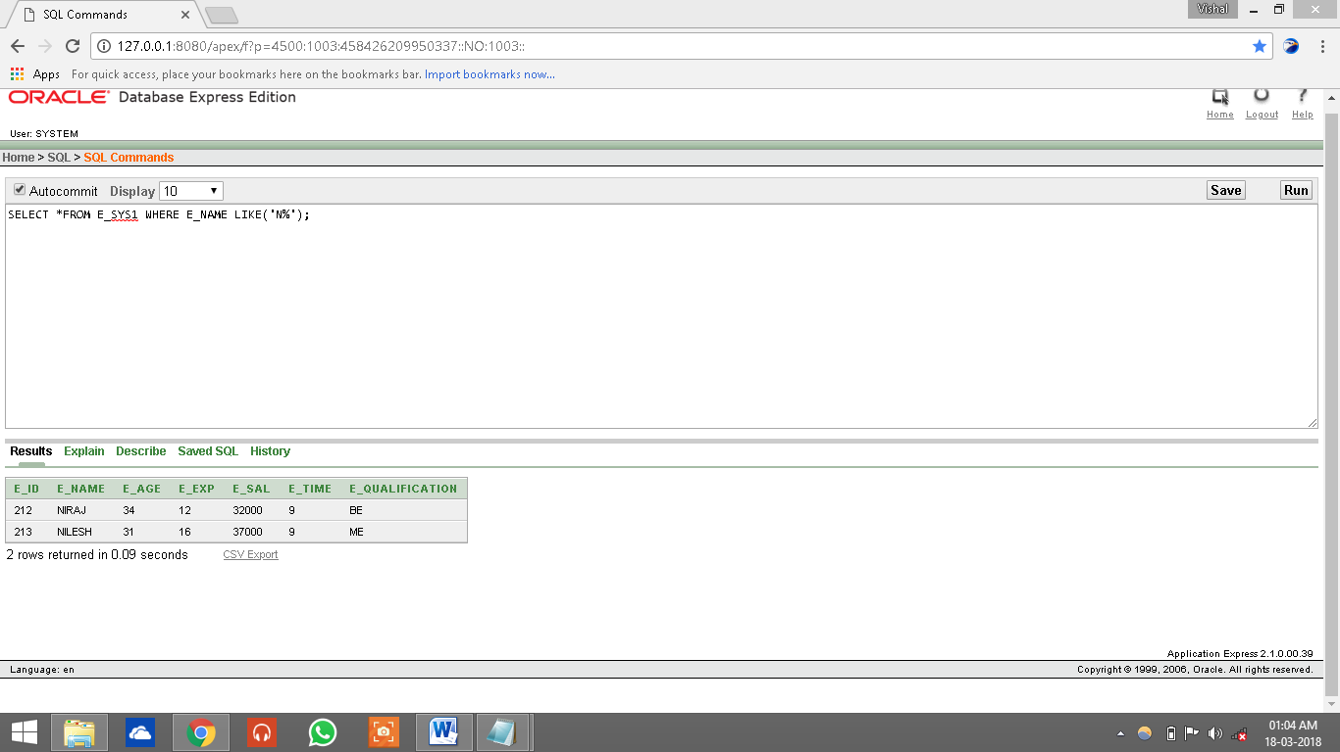

**<OR OPERATOR>**

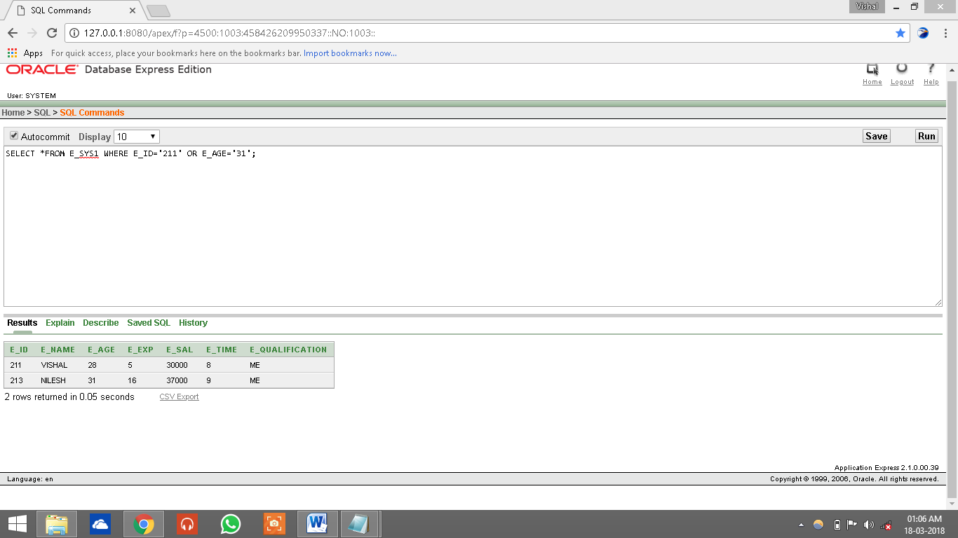

**3.NEGATING CONDITION**

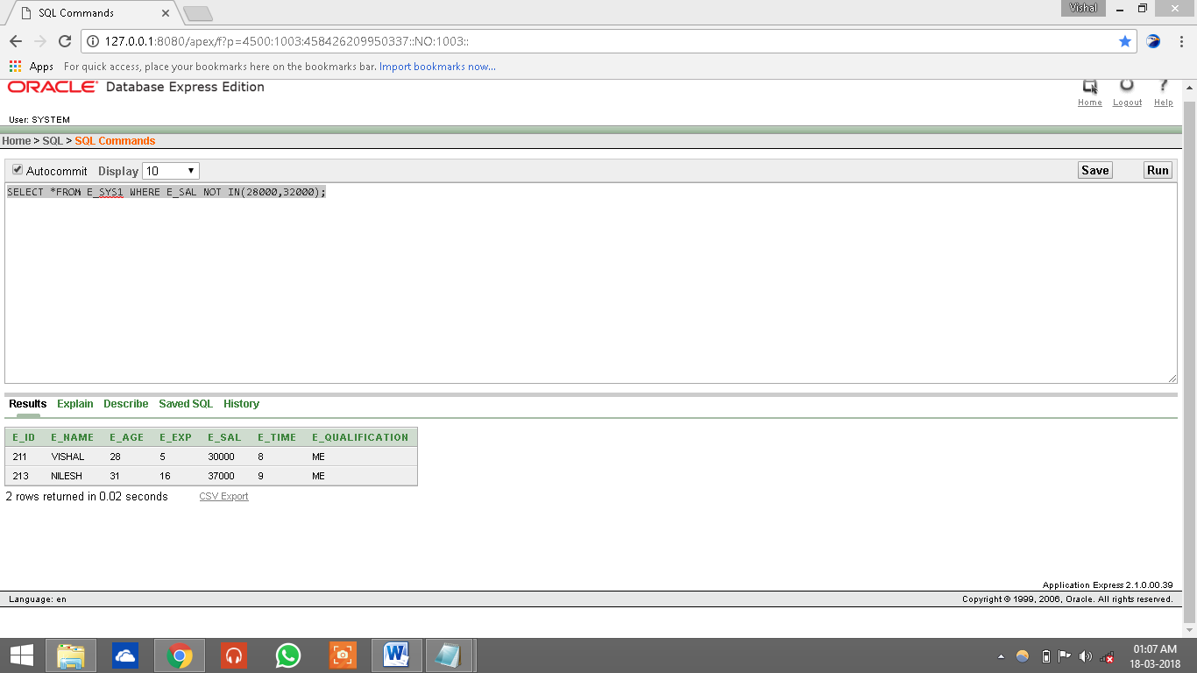

**4.ARITHMETIC OPERATOR:-**

**<SUBTRACTION OPERATOR>**

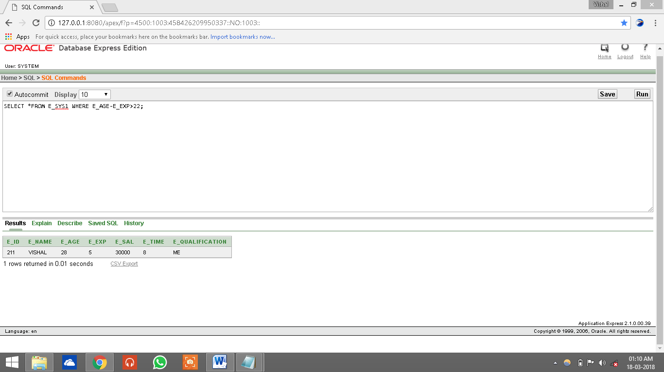

**<MULTIPLICATION OPERATOR>**

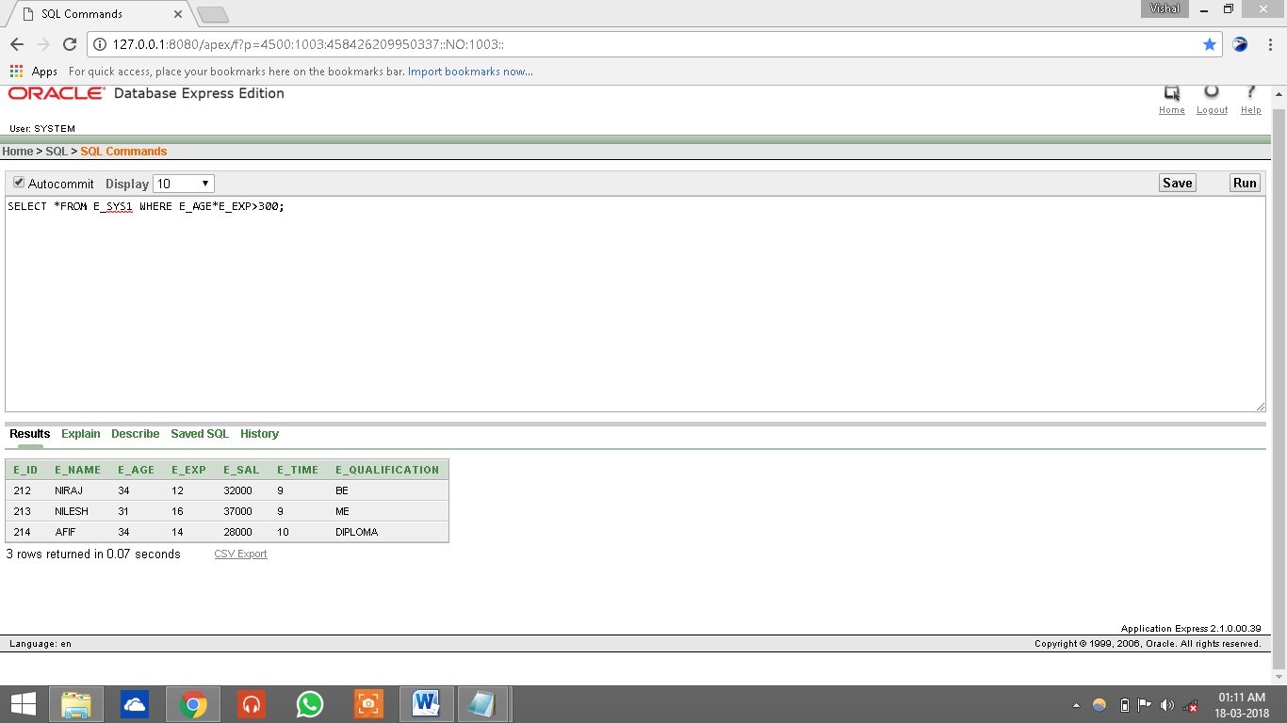

**FUNCTION IN SQL:**

**1.AGGREGATE FUNCTION:**

**1)COUNT FUNCTION:**

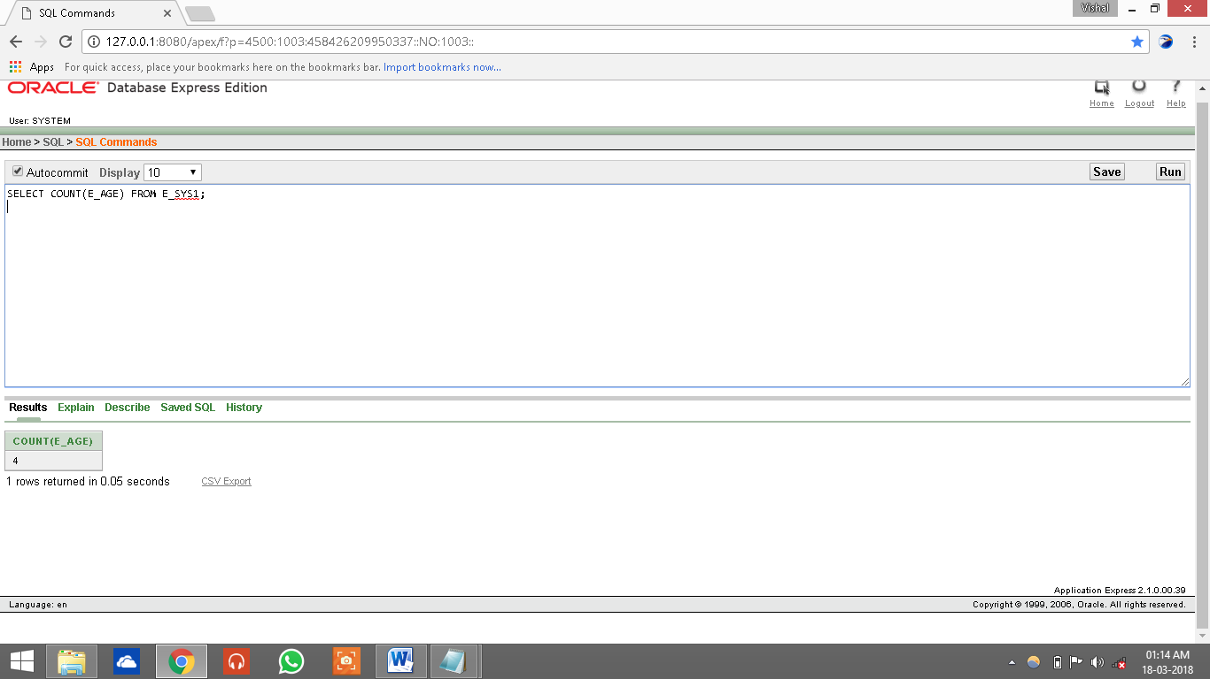

**2)SUM FUNCTION:**

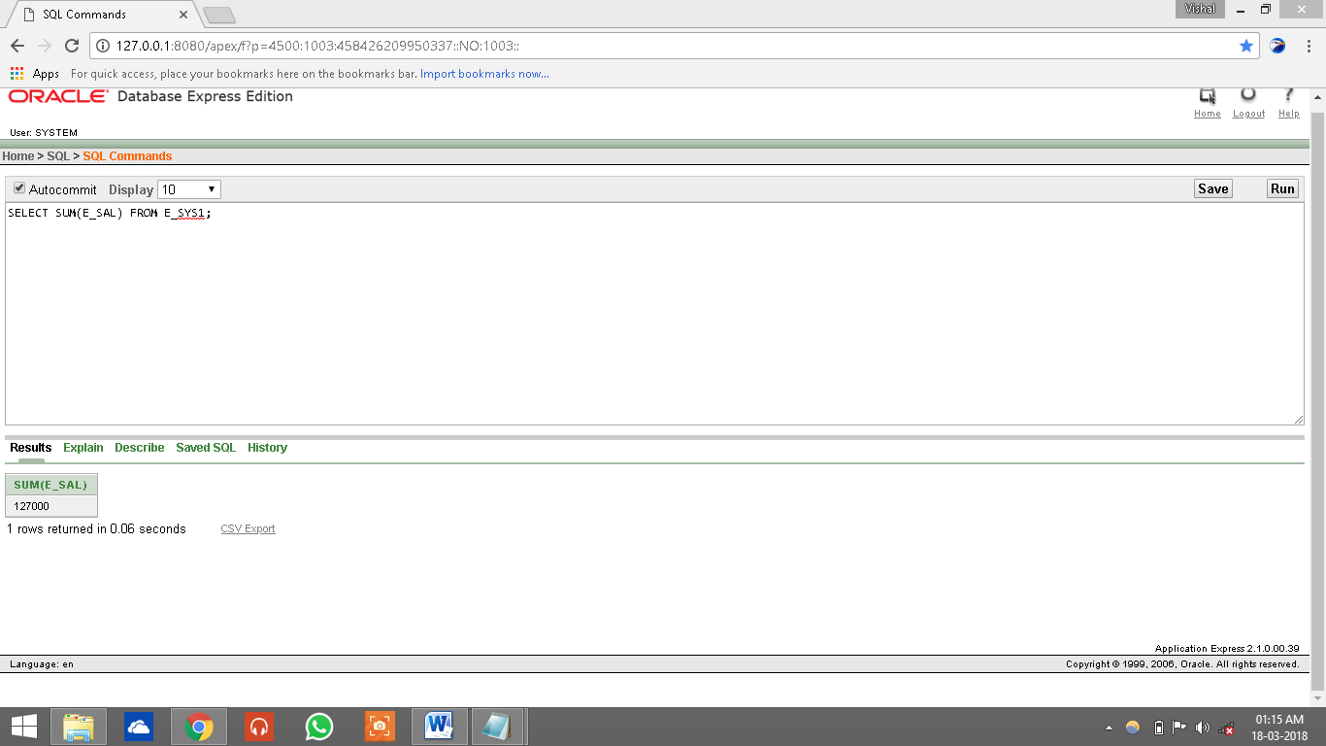

**3)MAXIMUM/MINIMUM FUNCTION:**

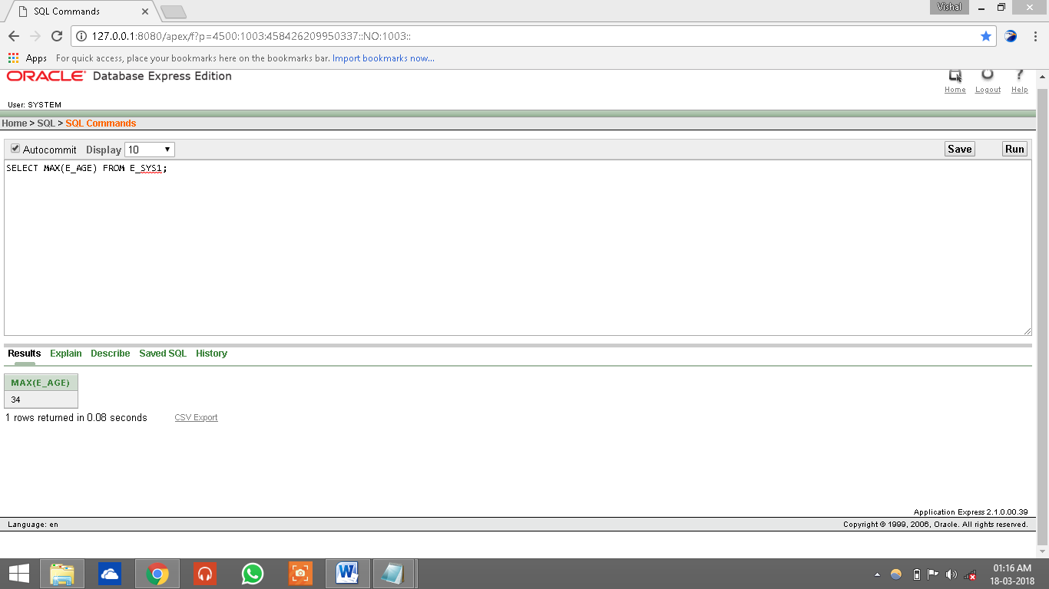

**4)AVERAGE FUNCTION:**

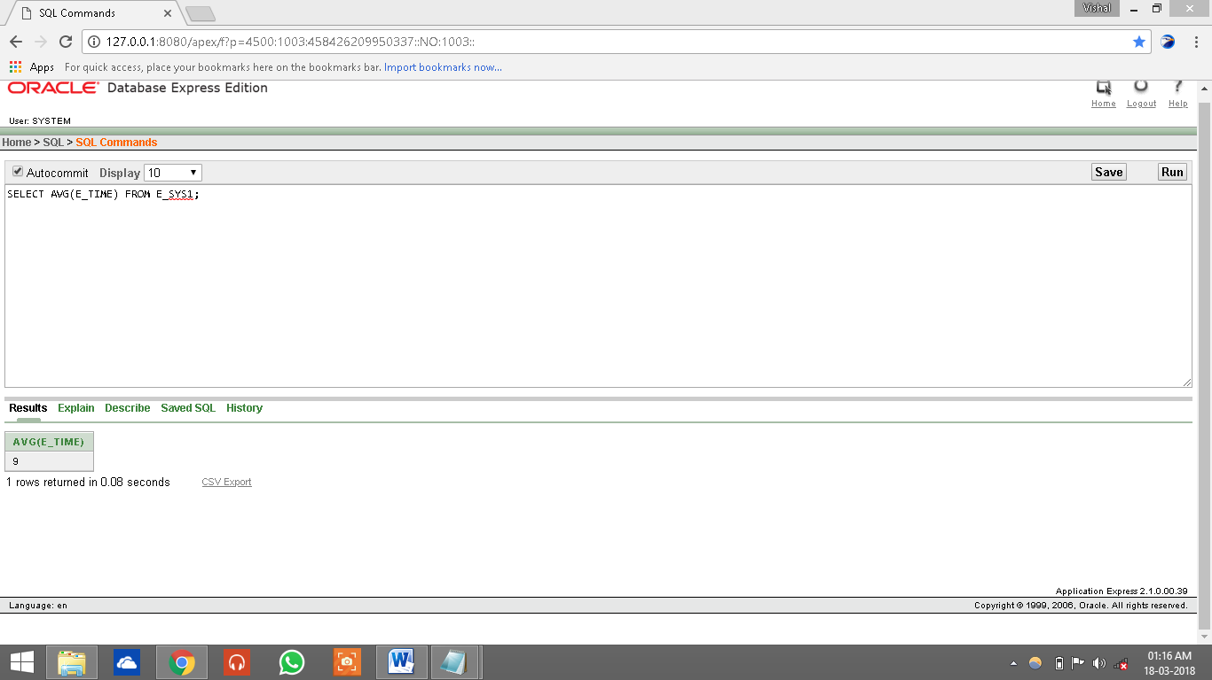

**2.STRING FUNCTION:**

**<UPPER CASE>**

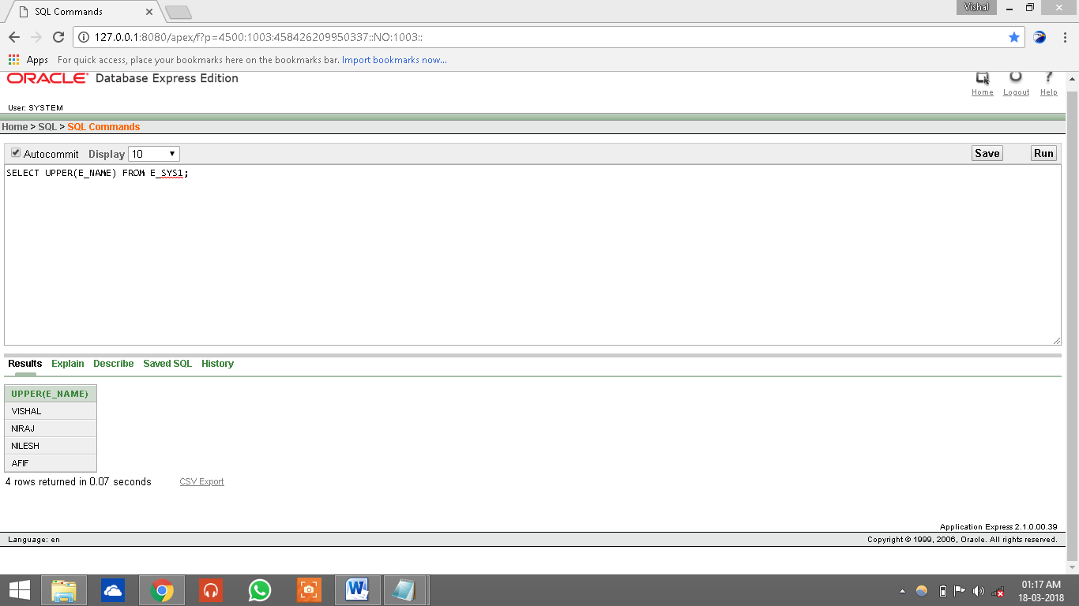

**<LOWER CASE>**

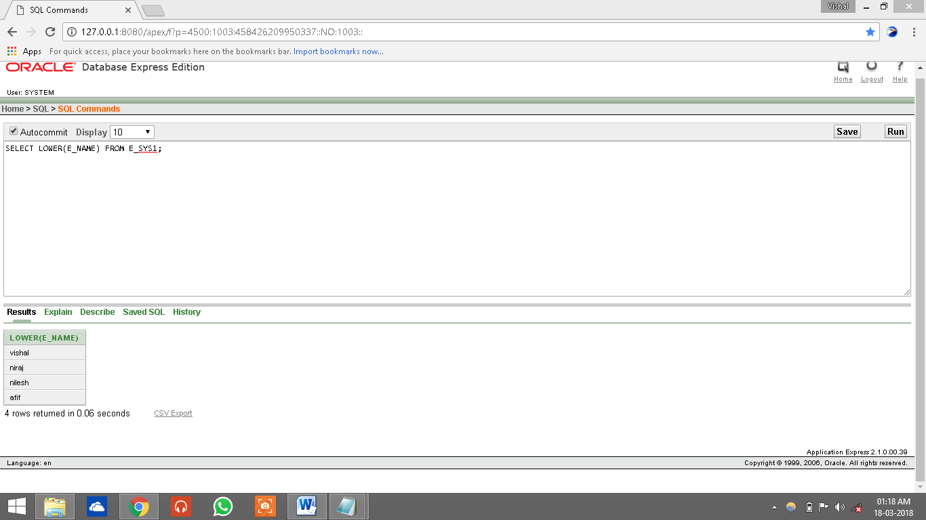

**CLAUSES:**

ORDER BY CLAUSE:

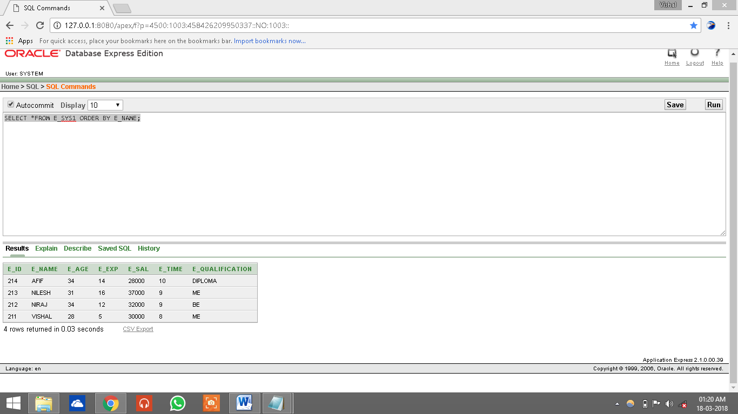

ORDER BY DESC:

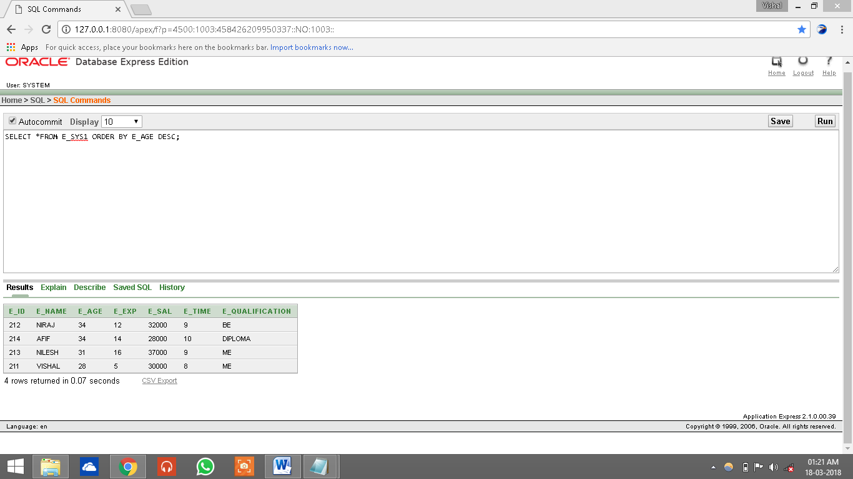

GROUP BY CLAUSE:

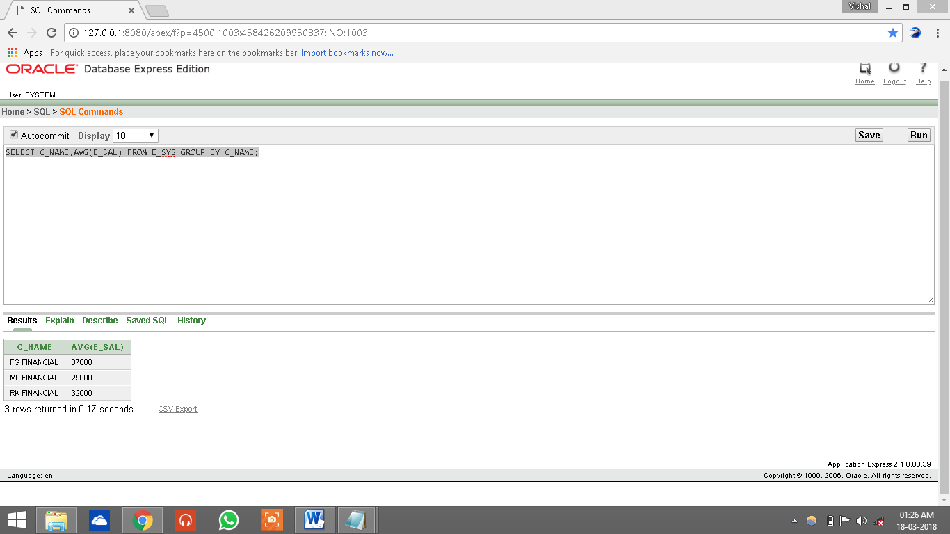

HAVING CLAUSE:

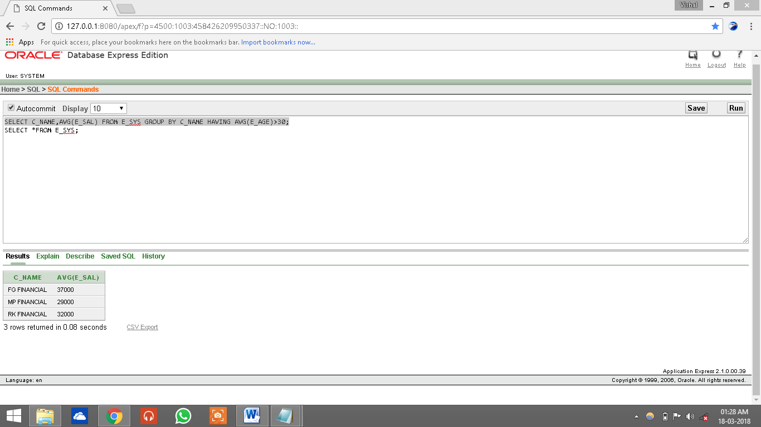

WHERE CLAUSE:

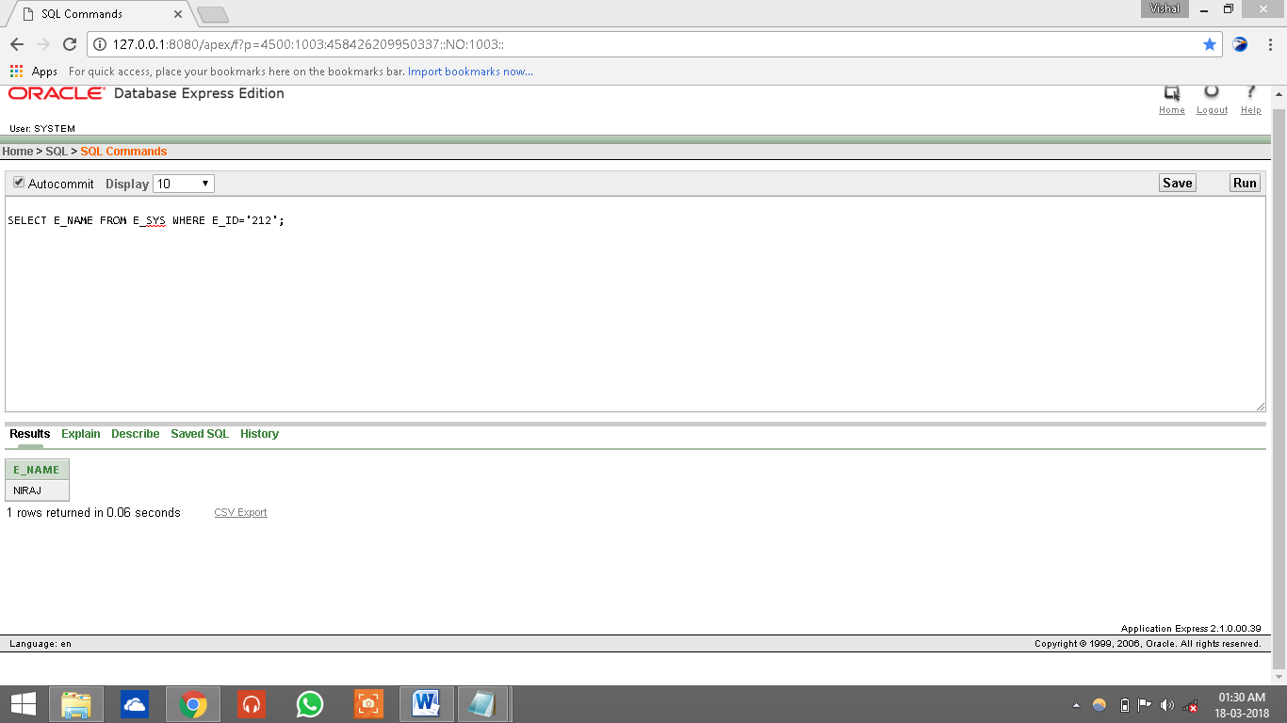

**SQL JOINS:**

**1)CROSS JOINS:-**

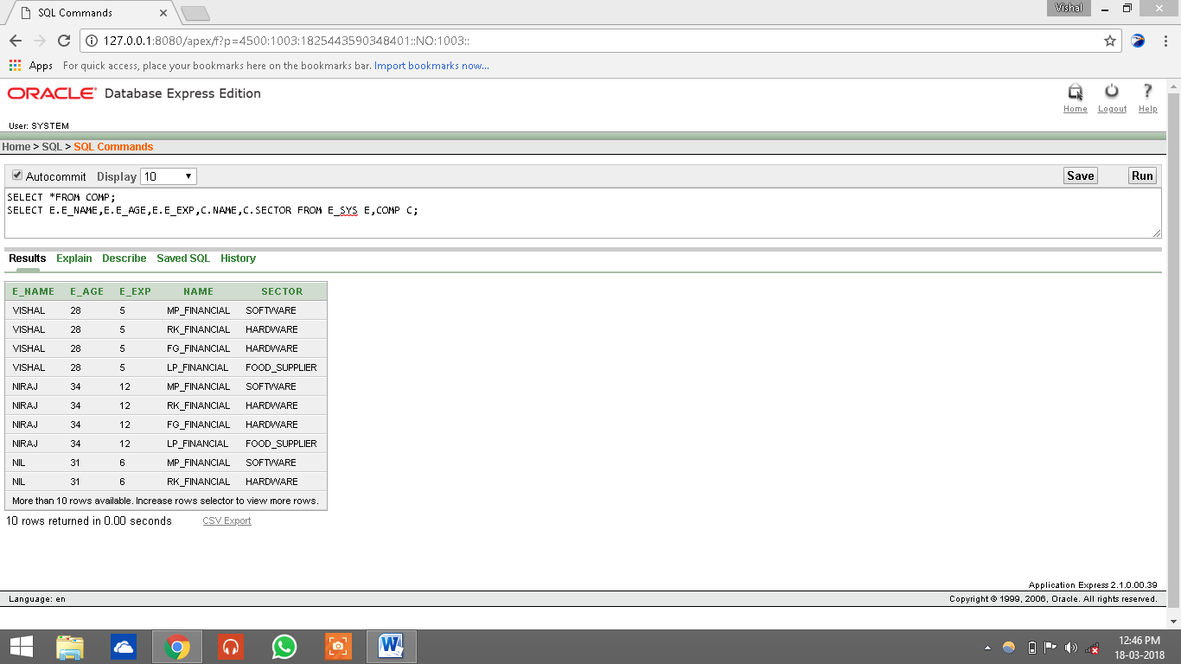

**2)INNER JOINS:-**

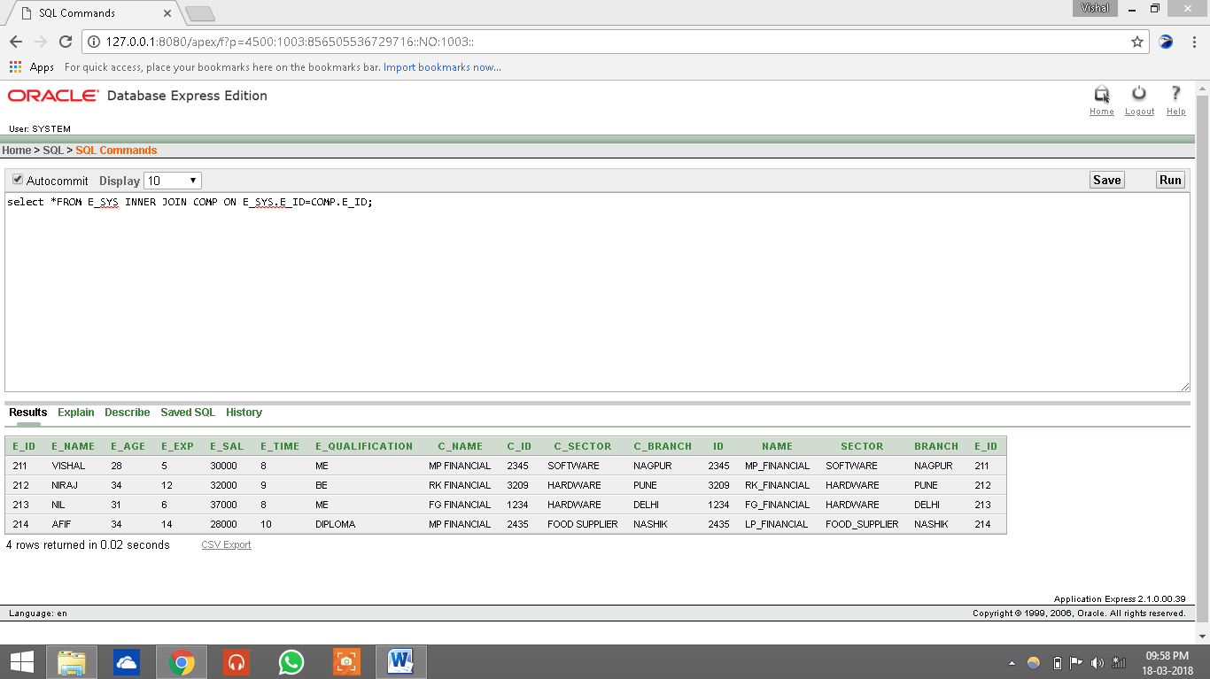

**3)OUTER JOINS(LEFT):-**

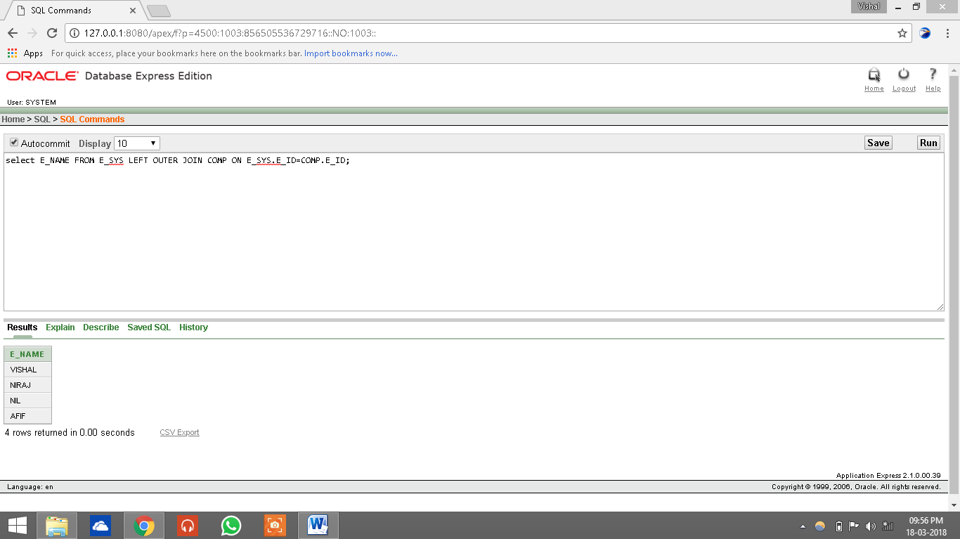

**4)OUTER JOIN(RIGHT):-**

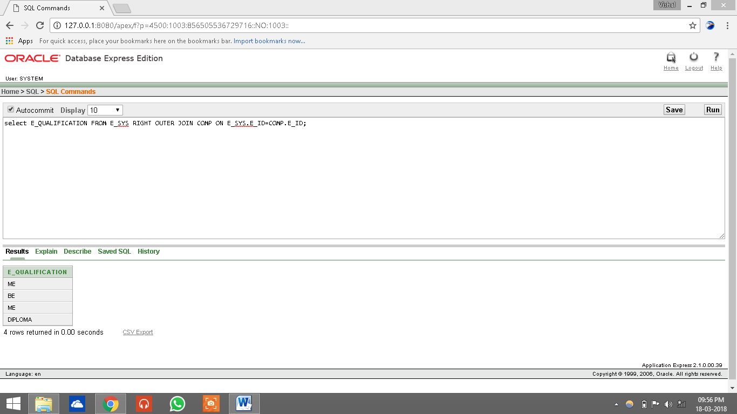

**5)OUTER JOIN(FULL):-**

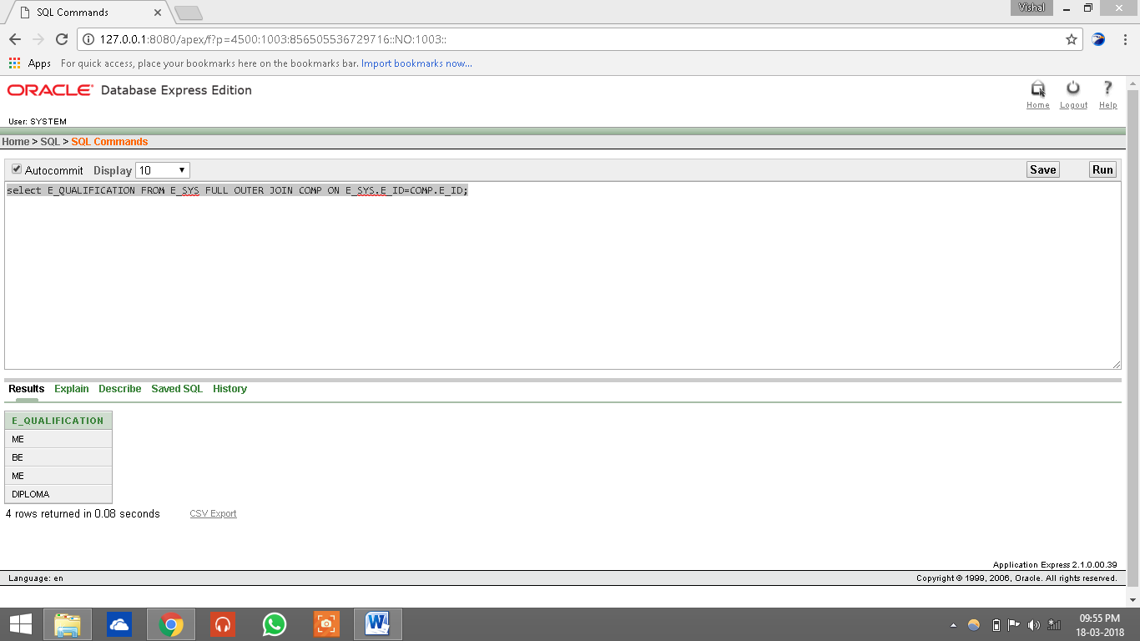

**VIEW:**

**CREATING VIEW:**

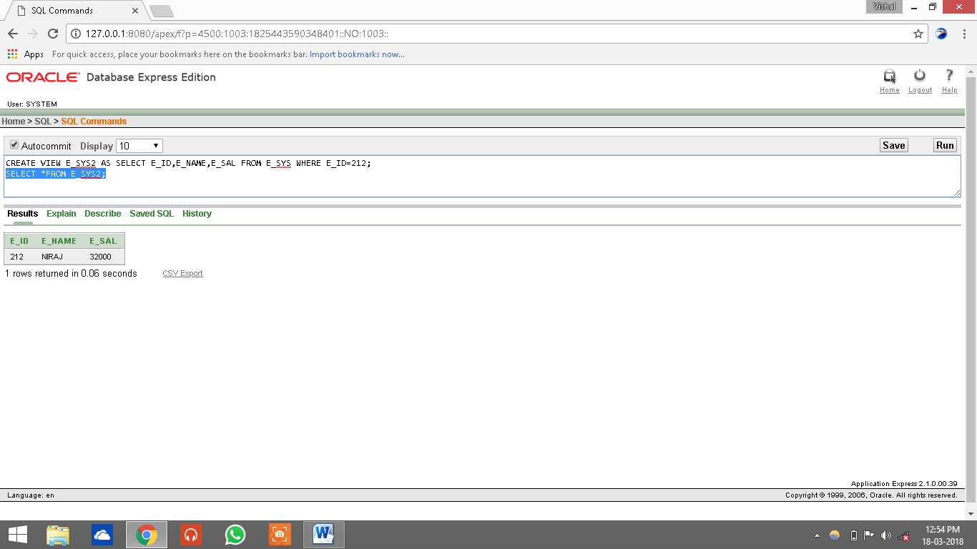

**UPDATING VIEW:**

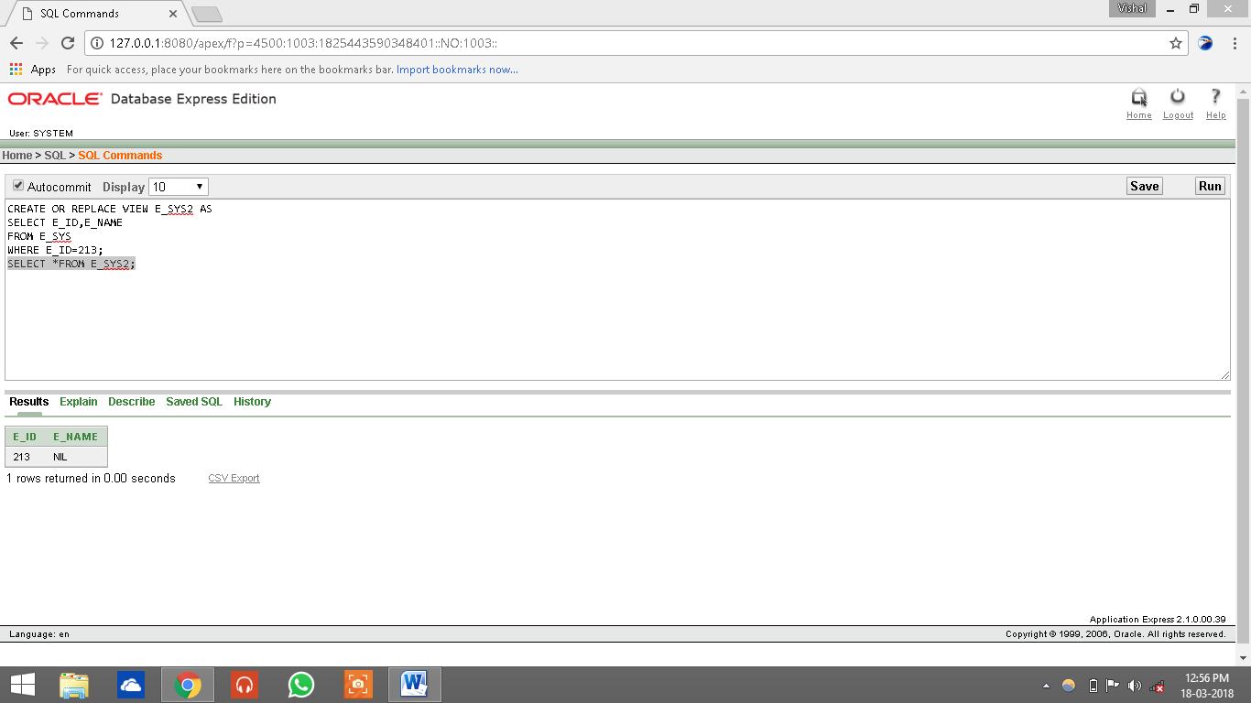

**DROPPING VIEW:**

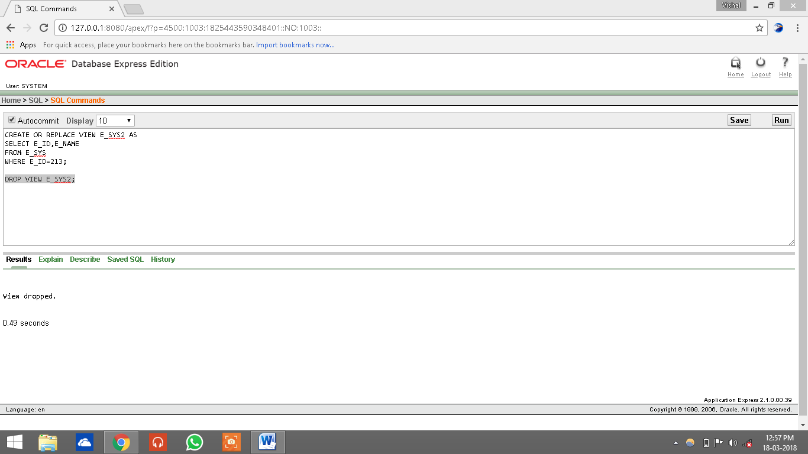

**INDEX**

**CREATE INDEX:-**

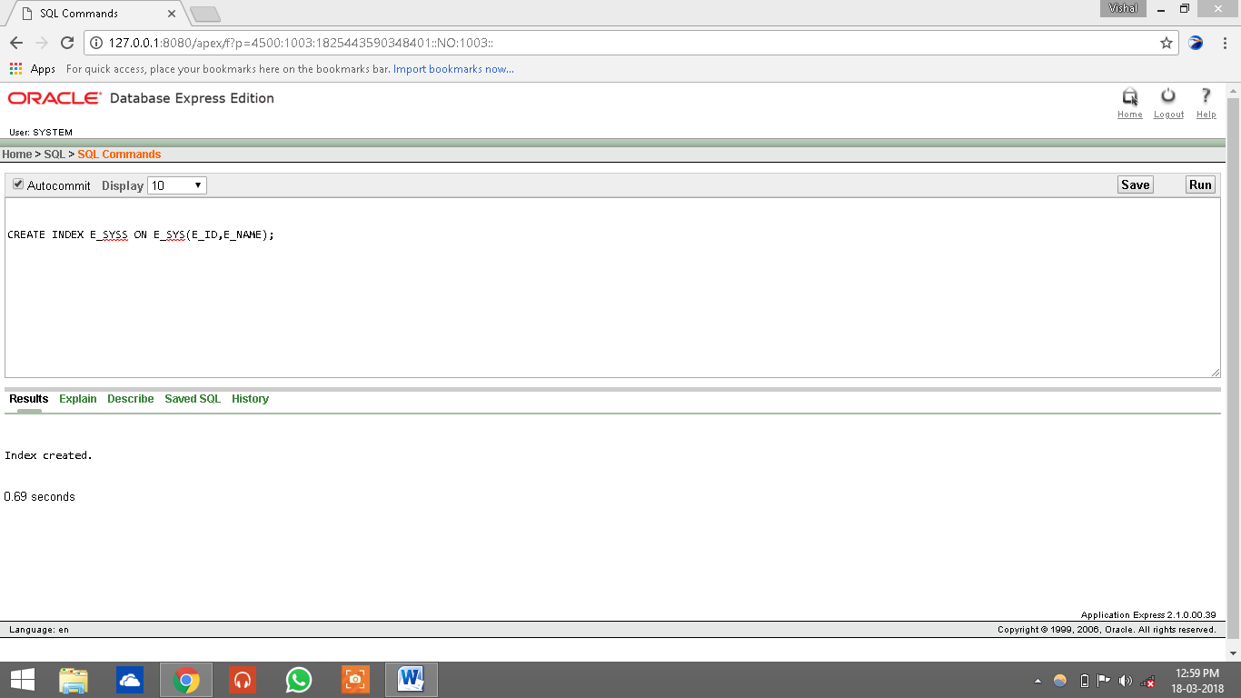

**DROPPING INDEX:-**

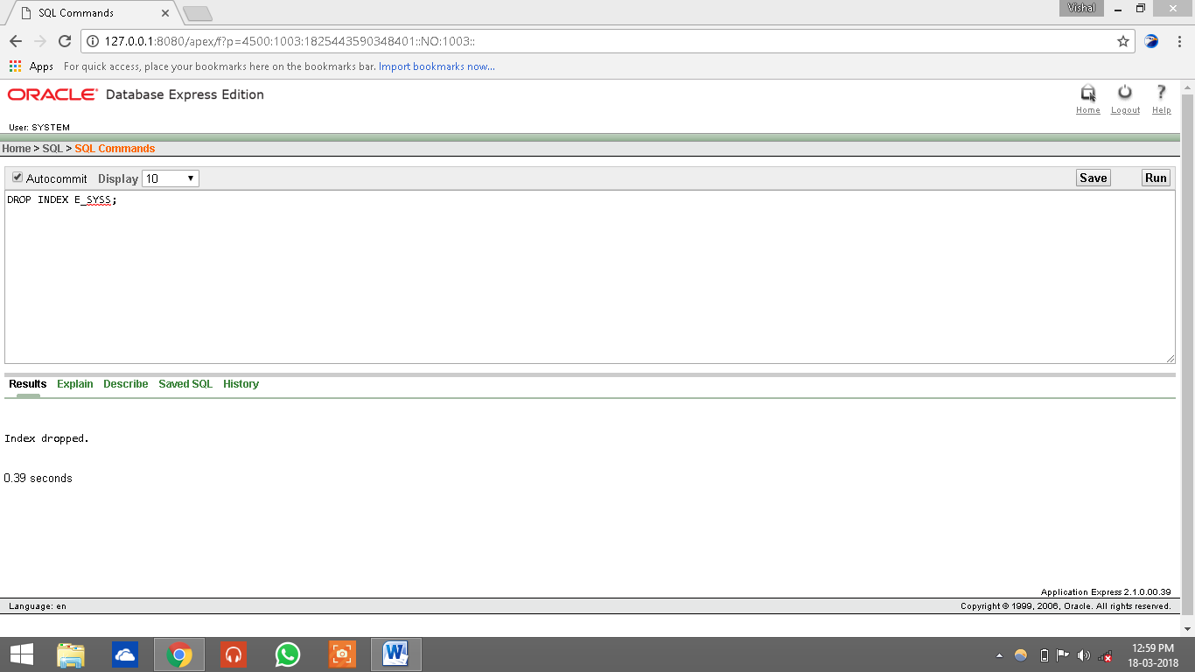

**SEQUENCE:**

**CRAETING SEQUENCE:-**

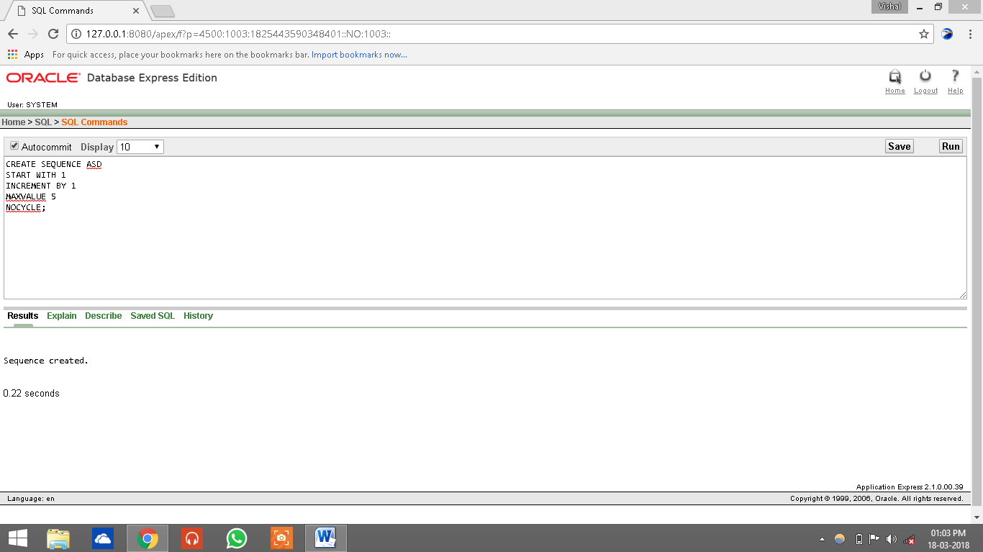

**TRIGGER:-**

